**JAVASCRIPT DEVELOPER TOOLS**

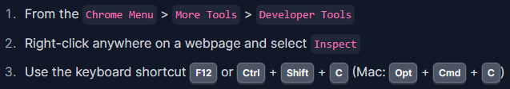There are three ways to open the Chrome DevTools menu:

Full link tutorial at Odin Assignment: <https://www.theodinproject.com/lessons/foundations-javascript-developer-tools>